**QSMART – COOLING GROUP REPLACEMENT**

**PROCEDURE**

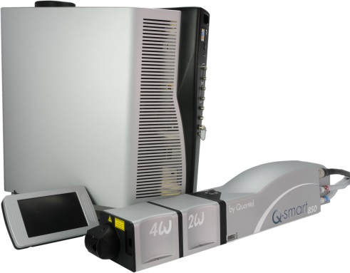

**Toolkit:**

Allen keys

**System** : QSMART

|  |  |  |  |  |  |  |  |  |  |
| --- | --- | --- | --- | --- | --- | --- | --- | --- | --- |
| |  |  | | --- | --- | | **SM010355** | **Q-SMART COOLING GROUP ASSEMBLY** | | | | |  |  |  |  |
|  |  |  |  |
|  |  |  |  |

**Purpose**: This document details how to change the COOLING GROUP

|  |  |  |
| --- | --- | --- |
| Revision | date | modification |
| Initial issue | July 4, 2014 |  |
|  |  |  |
|  |  |  |
|  |  |  |

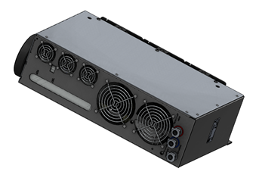

# DISASSEMBLY

## Unplug the system

* Remove the cap

## Unscrew the four screws, two at front and two on the rear side as indicated in the pictures

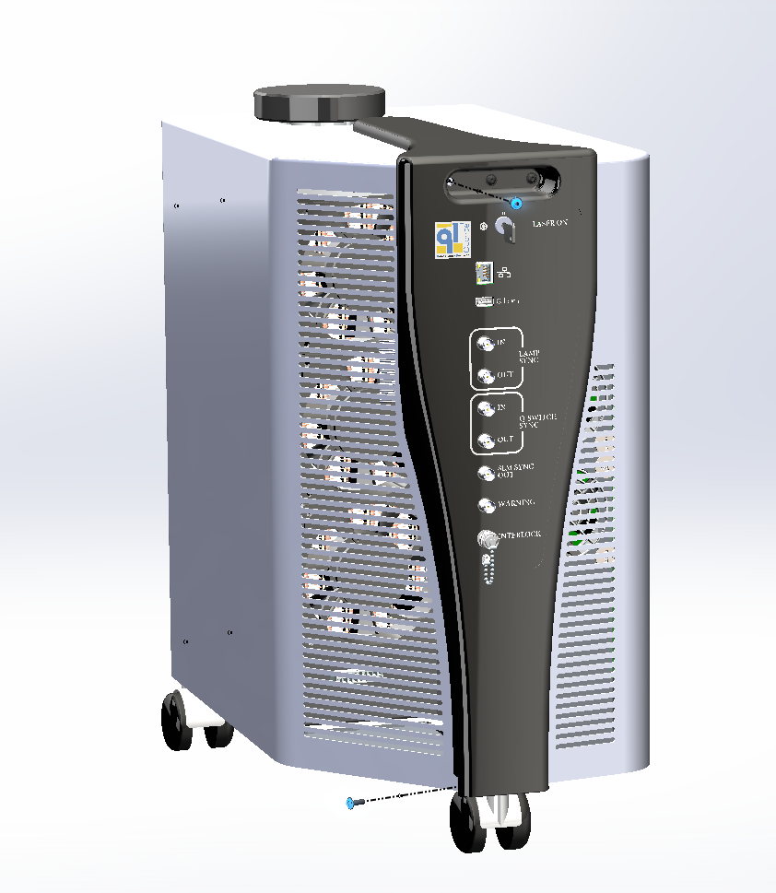

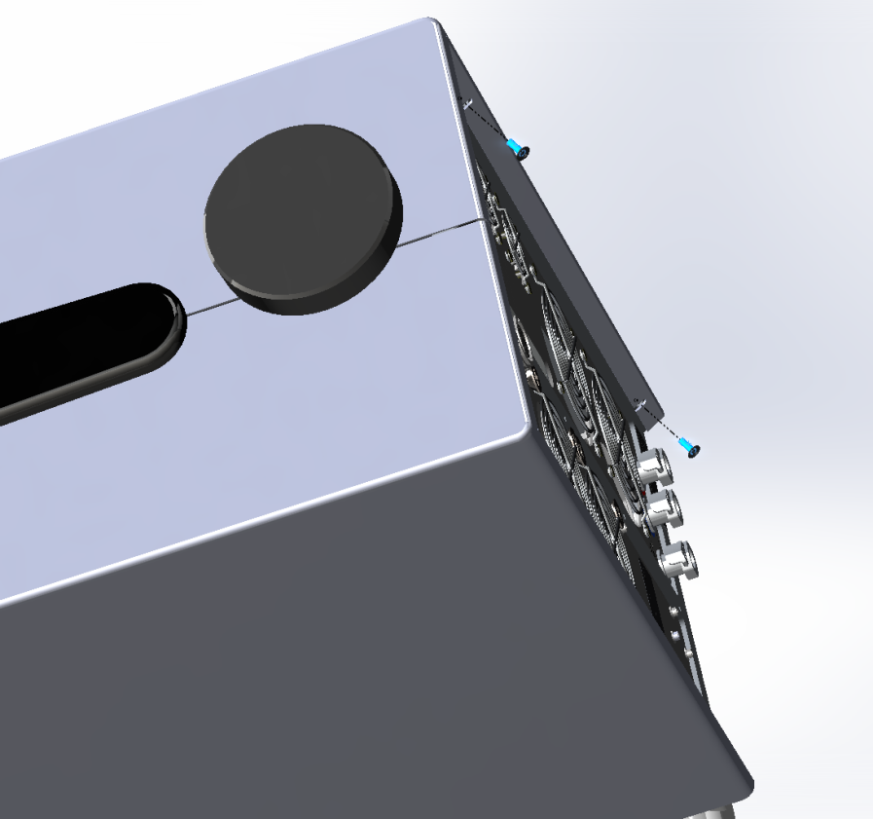

## Slide back the panel as indicated in the picture

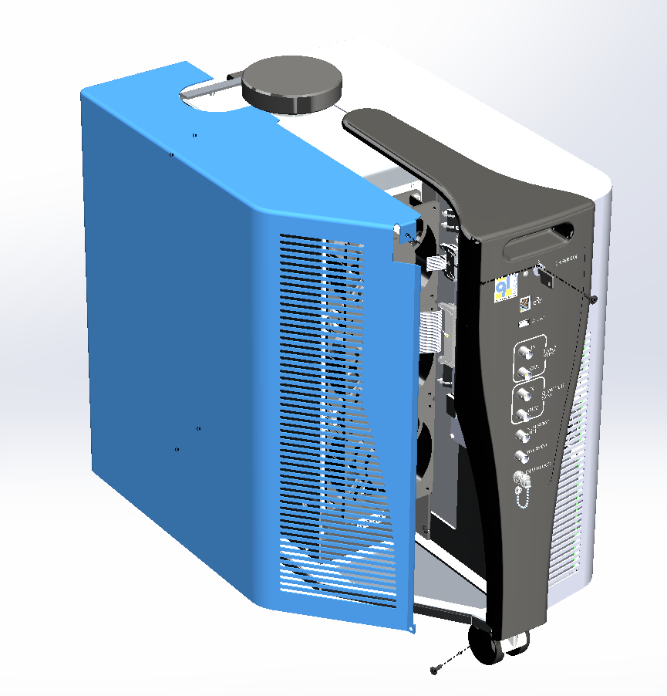

* Unscrew the 3 screws black 4x12 BHC (3/E13/0600) to remove the CG
* Disconnect the cables from the CG

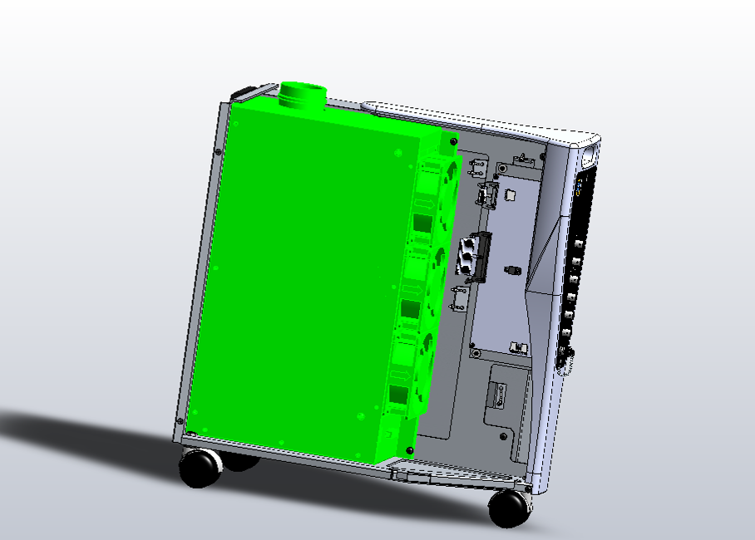

3/E13/0600

* Open CG by removing the locking plate (9 BHC M3x10)

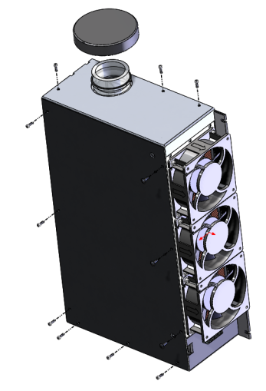

Unscrew the cap on the tank

Open CG by removing the locking plate (9 BHC M3x10)

Note: these 3 black BHC screws fasten the heater

# INSTALLATION OF COOLING GROUP

|  |  |  |
| --- | --- | --- |
| 3.00 | 3/E13/0600 | BLACK BHC 4x12 SCREW |

Fasten the CG to the chassis with 3 Black BHC 4x12 screws (3/E13/0600).



3/E13/0600

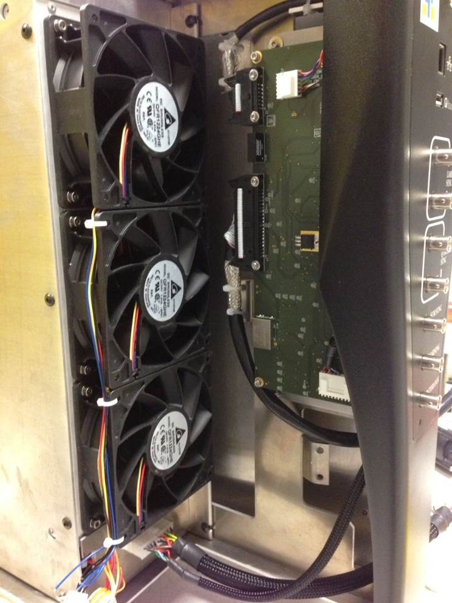

# CLOSING

|  |  |  |
| --- | --- | --- |
| 8.00 | 3/E13/0600 | BLACK BHC 4x12 SCREW |

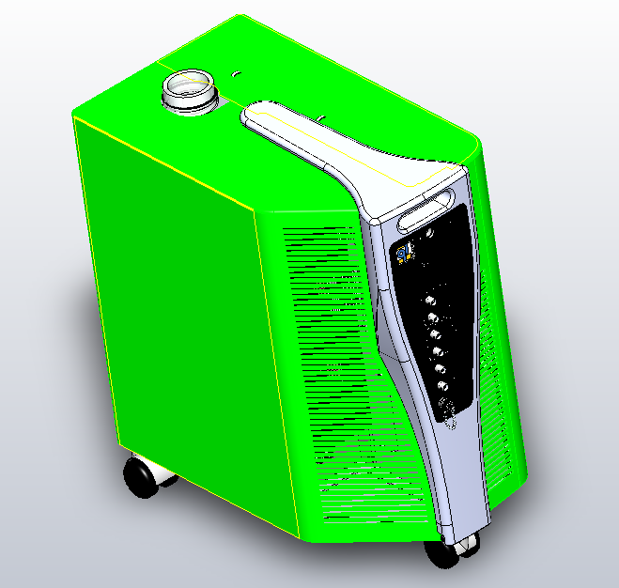

3/E13/0600

Implement both side panel and fasten with 8 BHC Black 4x12 (3/E13/0600) screws

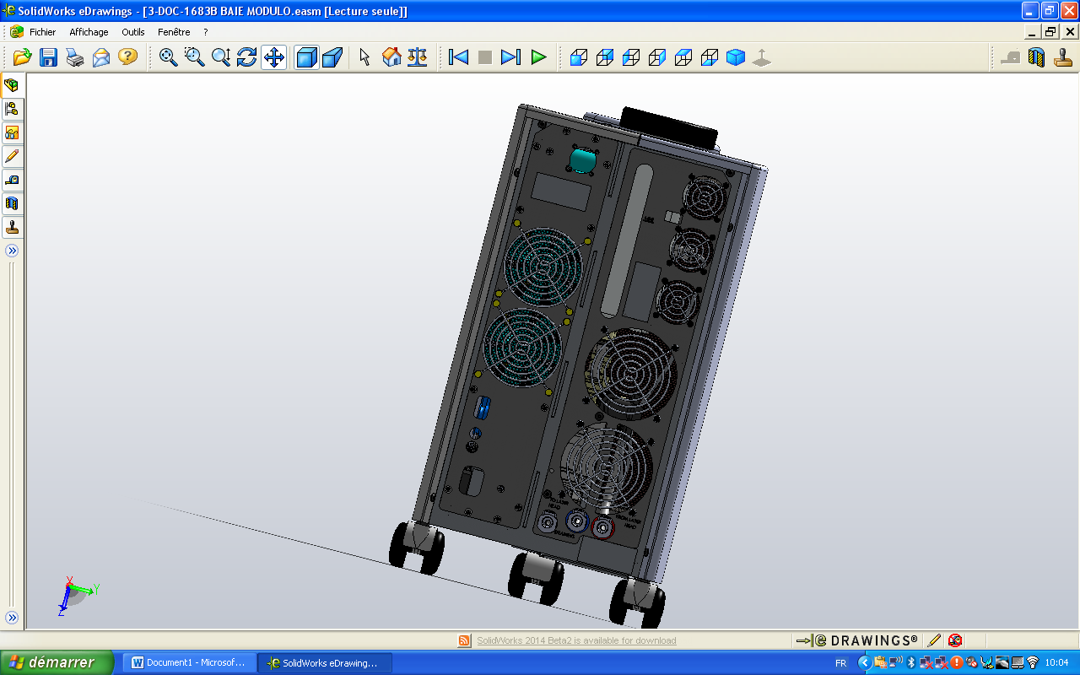

3/E13/0600

CAUTION: Leave a space between two covers

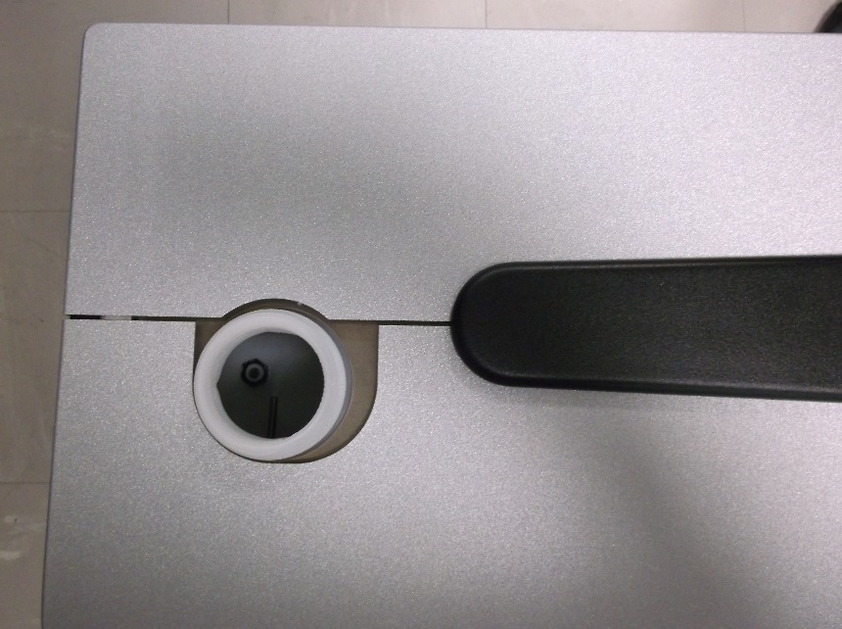

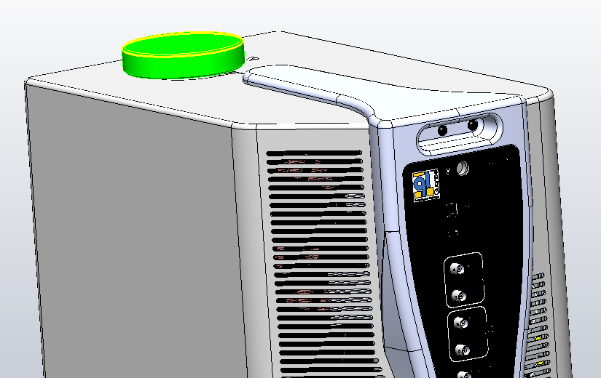

Reinstall the CG cap